Rutland Parent carer voice winter Newsletter 2019

Welcome to our winter 2019 newsletter!
As you will see from the contents of this newsletter, it has been a very busy year, with lots of events and commitments!
We have had to say a very sad goodbye one of our longest serving Steering Group (SG) member’s Claudi . However, we have welcomed two new SG members, Dean and Dionne.
I just want to take this opportunity to thank the members of our Steering Group, who all give up their free time to ensure Rutland SEND families are kept up to date and have a say in local SEND services.
Included in this newsletter are the comments from our members who attended a meeting with RCC’s transport team as well as the questions, with answers, our members submitted to RCC via our FB page.
Very warm regards
Melissa

We held our first Rutland Parent Carer Voice Live event in March, with lots of information stalls as well as practitioners invited from Rutland County Council (RCC) , Health and social care. This also gave members the opportunity to pose questions to RCC which were answered and published on the local offer.

In the summer we welcomed many Rutland SEND families to Rutland Farm Park for exclusive access to the park for the day. Feedback from this was that everyone had a great day, and we would like to thank Rutland Farm Park for giving us exclusive rights to their facilities.

National news
The latest Department for Education SEND Newsletter can be found via the Council for Disabled Children’s website http://www.nnpcf.org.uk/

local news
In October two members of our steering group met with the Transport Department at RCC , along with another member of the team at RCC to discuss questions that have been raised recently by some of our members. These are as follows:

Q. Who makes the decision into who is entitled to transport?
- This is down to SEND case Officers who ultimately make the decision. If a child is needing an escort to get to their place of education this is also down to the Case Officers.

Q. How do we apply and get information as to whether there is eligibility for personal transport budgets?
- Interested parents need to contact transport. If there is a mode of transport going to the education facility already, there would have to be extra circumstances for an individual child to be paid in addition to. Again, this is considered with close liaison with the child's case officer. Payment is currently 45p per mile and is as the crow flies which is the same rule that the Local Authority use to decide nearest catchment school.
RCC Transport Department reported that the next policy to be reviewed is the Post 16 transport, being scheduled for Easter next year. A three-month consultation will take place. We will publish more information about this when we receive it.

Transport have also been rolling out further independence travel training, working with students at Catmose College with plans to increase, with parents and student's agreement.
RPCV have agreed to meet again at the end of the summer term next year to see if any further improvements in communication to parents can be done. This year the forms for students have been sent out for information on the students and Transport are hoping for a higher return rate next year.

Transforming Emotional, Mental Health & Wellbeing services for Children and Young People
In November, representatives from the NHS came to give a presentation on the plan for Emotional, Mental health and wellbeing services for Children and Young Peoples services, the presentation has been emailed out to all members on the mailing list, and feedback is being requested at present into how you see these services will work. We of course will keep up updated with any future updates.

SEND Peer Review
Three members of our Steering Group attended Rutland County Council’s Peer Review, in preparation for this we asked for questions, comments and feedback that we could take with us via our social media page. These have all been given to Rutland County Council who have responded and these are attached to this newsletter as well as being published on the local offer. RCC encourage you to please continue to ask questions via Rutland Parent Carer Voice and we will pass these on to be answered.

DATES FOR YOUR DIARY

24 January 10 am until 1pm, Anxious Child- Understanding Anxiety workshop
31 January 10am until 1pm Emotional Literacy workshop
7 February 10am until 1pm Parent Well-being Workshop
28th February Understanding Behaviour workshop
All events will be held at Voluntary Action Rutland, will include a light lunch and be promoted through Eventbrite.
We look forward to seeing you there.

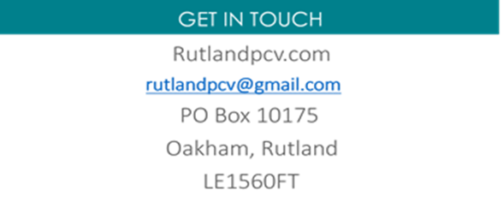
We would like to thank you all for your continued support for the forum and for getting involved with the work we do - we really couldn’t do it without you!

